IMovies
Movie Ticket Booking System (MERN Stack)
Data Flow Diagrams and Solution Requirements (Functional & Non-Functional)
Date: 28 October 2026

1. Introduction

1.1 Purpose
This document describes the IMovies online movie ticket booking system. It presents the Data Flow Diagrams (DFD Level 0, Level 1 and Level 2) and the solution requirements (functional and non-functional) of the system, derived from the implemented project.

1.2 Scope
IMovies lets users browse movies, view upcoming showtimes, choose seats on a live seat map and book tickets. Users can view and cancel their bookings. An administrator manages movies and showtimes. The system is a web application with a React front end, an Express REST API and a MongoDB database.

1.3 Technology Stack
Layer | Technology
Front end | React 18, React Router 6, Axios, Bootstrap 5, built with Vite
Back end | Node.js, Express 4, Mongoose 8, JSON Web Tokens (jsonwebtoken), bcryptjs, CORS, dotenv
Database | MongoDB (local installation or MongoDB Atlas)
Tools | Node.js 16+, npm 8+, VS Code, Postman (optional)

1.4 User Classes
User | Description
Visitor (guest) | Can browse and search movies, view movie details, showtimes and the seat map. Must register or log in to book.
Customer (registered user) | Can book seats, view booking history and cancel bookings.
Admin | Can add, update and delete movies and add or delete showtimes. Admin accounts are created by the seed script.

2. Data Flow Diagrams

2.1 Notation
Symbol | Meaning
Rectangle | External entity (source or destination of data outside the system)
Circle | Process (transforms incoming data into outgoing data)
Open-ended rectangle (D1, D2 …) | Data store (a MongoDB collection)
Arrow | Data flow. A double-headed arrow between an entity and a process shows both the request (before the “/”) and the response (after the “/”).
Dashed arrow | Side effect or recovery action

2.2 External Entities and Data Stores
Name | Description
Customer (User) | Visitor or registered user who browses movies and books tickets.
Admin | Manages the movie catalogue and showtimes.
D1 Users | name, email, hashed password, role (user / admin)
D2 Movies | title, description, genres, language, duration, rating, poster, release date
D3 Showtimes | movie, screen, start time, ticket price, seat rows and columns, list of booked seats
D4 Bookings | user, movie, showtime, seats, total amount, status (booked / cancelled)

2.3 Level 0 DFD (Context Diagram)
The whole system is shown as a single process that interacts with two external entities: the Customer and the Admin.
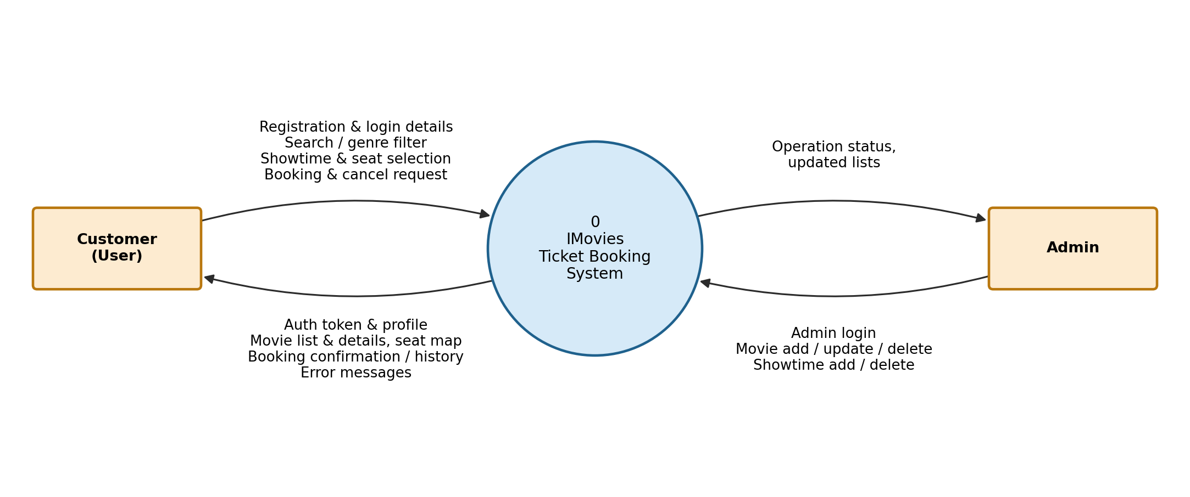
Figure 1: Level 0 DFD – IMovies Ticket Booking System

2.4 Level 1 DFD
The system is decomposed into five main processes. Data flows from the Customer and Admin pass through these processes to the four data stores.
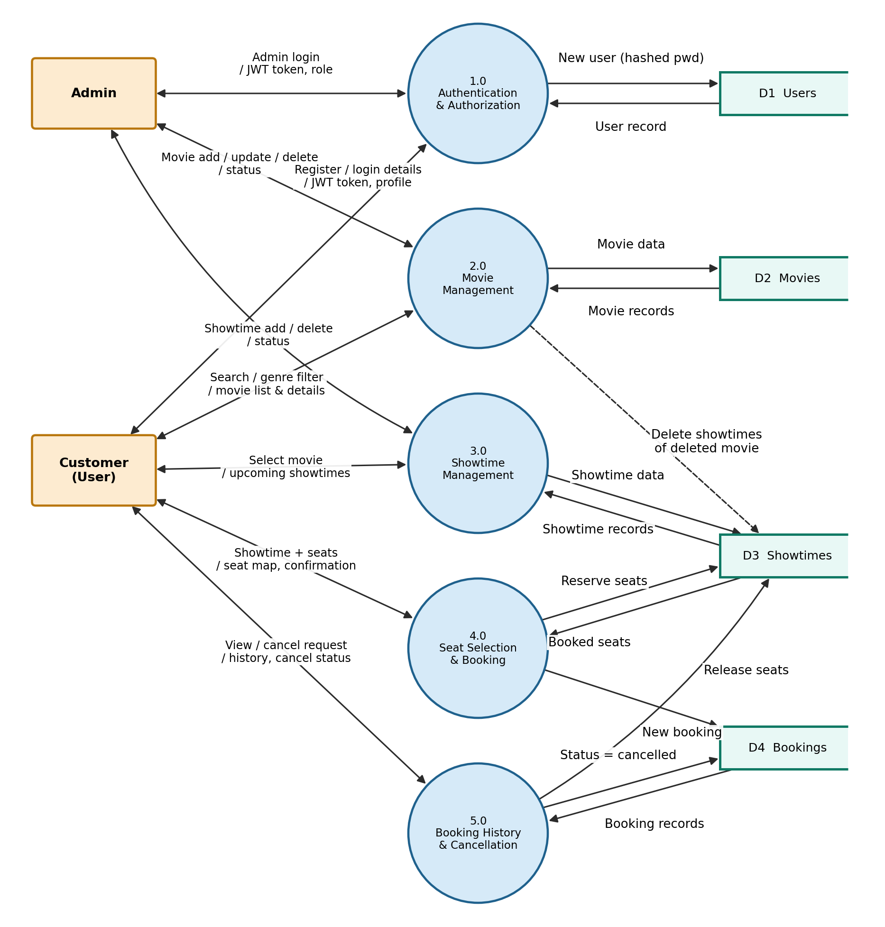
Figure 2: Level 1 DFD – IMovies Ticket Booking System

Process descriptions (Level 1)
Process | Description | Input | Output | Data stores
1.0 Authentication & Authorization | Registers users, verifies login credentials, issues a JWT and checks the token and role on protected routes. | Register / login details, token | JWT token, profile, error messages | D1
2.0 Movie Management | Lists, searches and filters movies and shows movie details. Admin adds, updates and deletes movies; deleting a movie also removes its showtimes. | Search text, genre, movie details | Movie list, movie details, status | D2, D3
3.0 Showtime Management | Shows upcoming showtimes of a movie. Admin adds and deletes showtimes. | Movie selection, showtime details | Showtime list, status | D3
4.0 Seat Selection & Booking | Displays the seat map, validates the request, reserves seats atomically and creates the booking. | Showtime, selected seats | Seat map, booking confirmation, errors | D3, D4
5.0 Booking History & Cancellation | Lists the user’s bookings and cancels a booking, releasing its seats. | View / cancel request | Booking history, cancellation status | D3, D4

2.5 Level 2 DFD – Process 4.0 Seat Selection & Booking
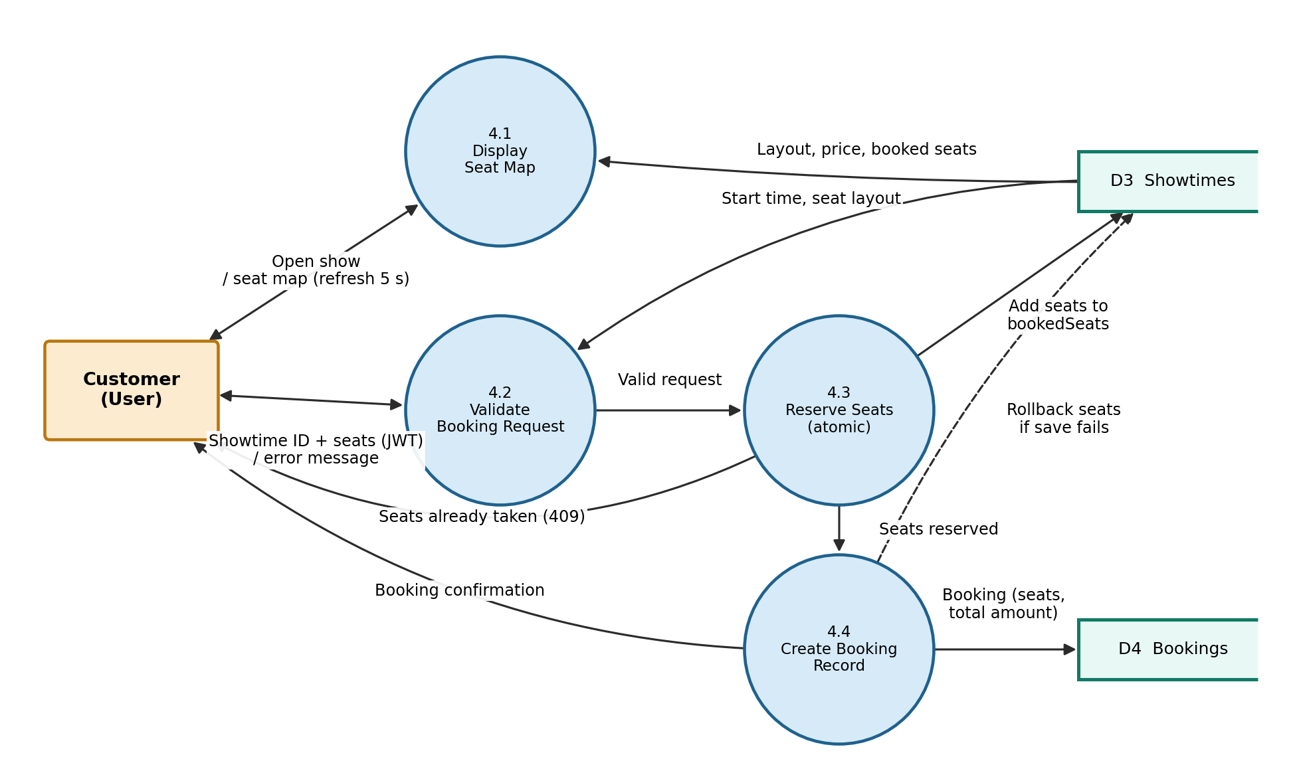
Figure 3: Level 2 DFD – Process 4.0 Seat Selection & Booking

2.6 Level 2 DFD – Process 5.0 Booking History & Cancellation
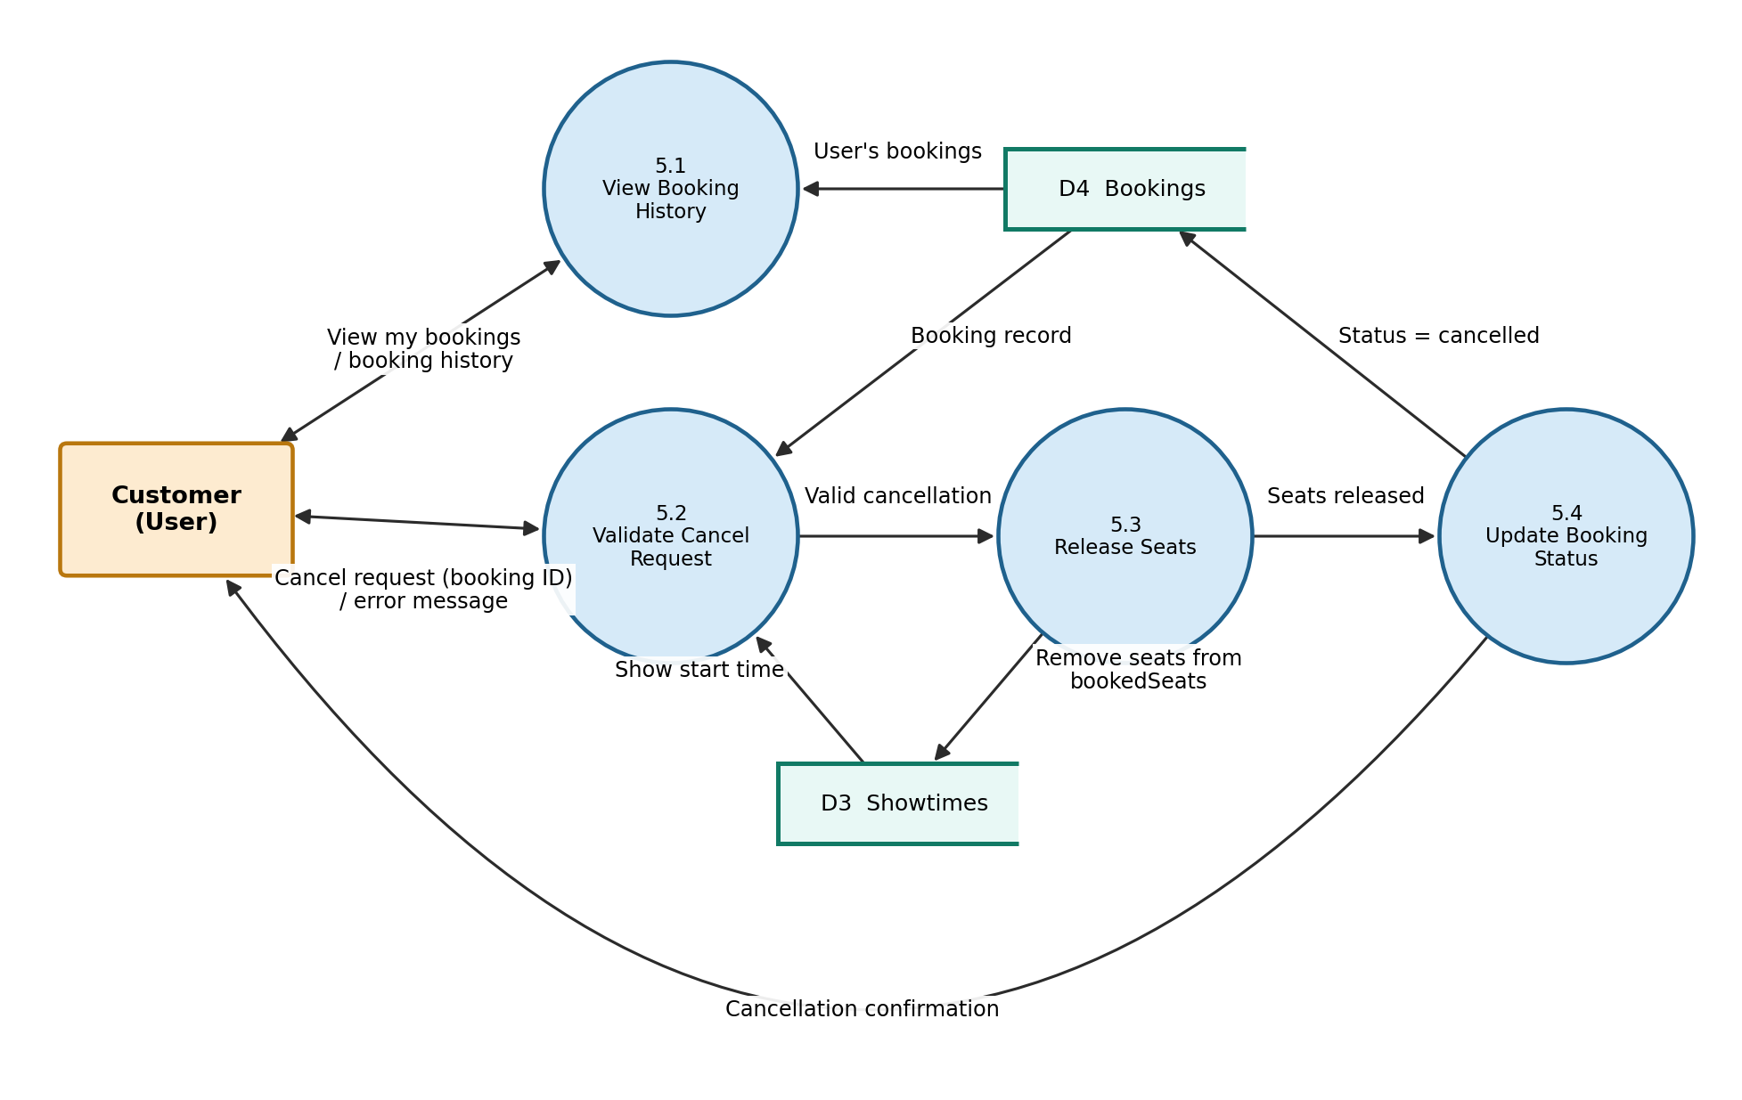
Figure 4: Level 2 DFD – Process 5.0 Booking History & Cancellation

Process descriptions (Level 2)
Process | Description | Data stores
4.1 Display Seat Map | Shows the seat grid of a showtime with booked seats marked. The map refreshes every 5 seconds so availability stays current. | D3 (read)
4.2 Validate Booking Request | Checks the user’s token, that at least one seat is chosen (maximum 8), that the showtime exists and has not started, and that every seat code is valid for the layout. | D3 (read)
4.3 Reserve Seats | Atomically adds the seats to the showtime only if none of them is already booked. If any seat is taken, the request is rejected with a conflict message. | D3 (update)
4.4 Create Booking Record | Saves the booking with seats, total amount (seats × price) and status “booked”. If saving fails, the reserved seats are released. | D4 (write), D3 (rollback)
5.1 View Booking History | Returns the logged-in user’s bookings with movie and showtime details, newest first. | D4 (read)
5.2 Validate Cancel Request | Checks that the booking belongs to the user, is not already cancelled and that the show has not started. | D4, D3 (read)
5.3 Release Seats | Removes the booking’s seats from the showtime so others can book them. | D3 (update)
5.4 Update Booking Status | Sets the booking status to “cancelled” (the record is kept) and confirms to the user. | D4 (update)

